**Table – EmployeeDetails**

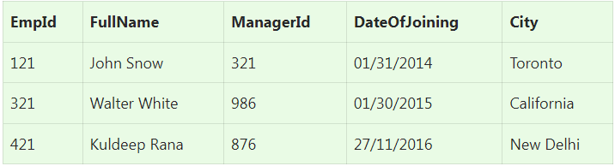

**Table – EmployeeSalary**

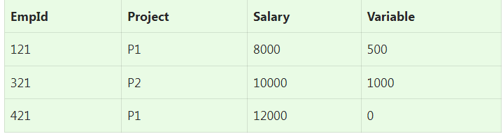

**Ques.1. Write an SQL query to fetch the EmpId and FullName of all the employees working under Manager with id – ‘876’.**

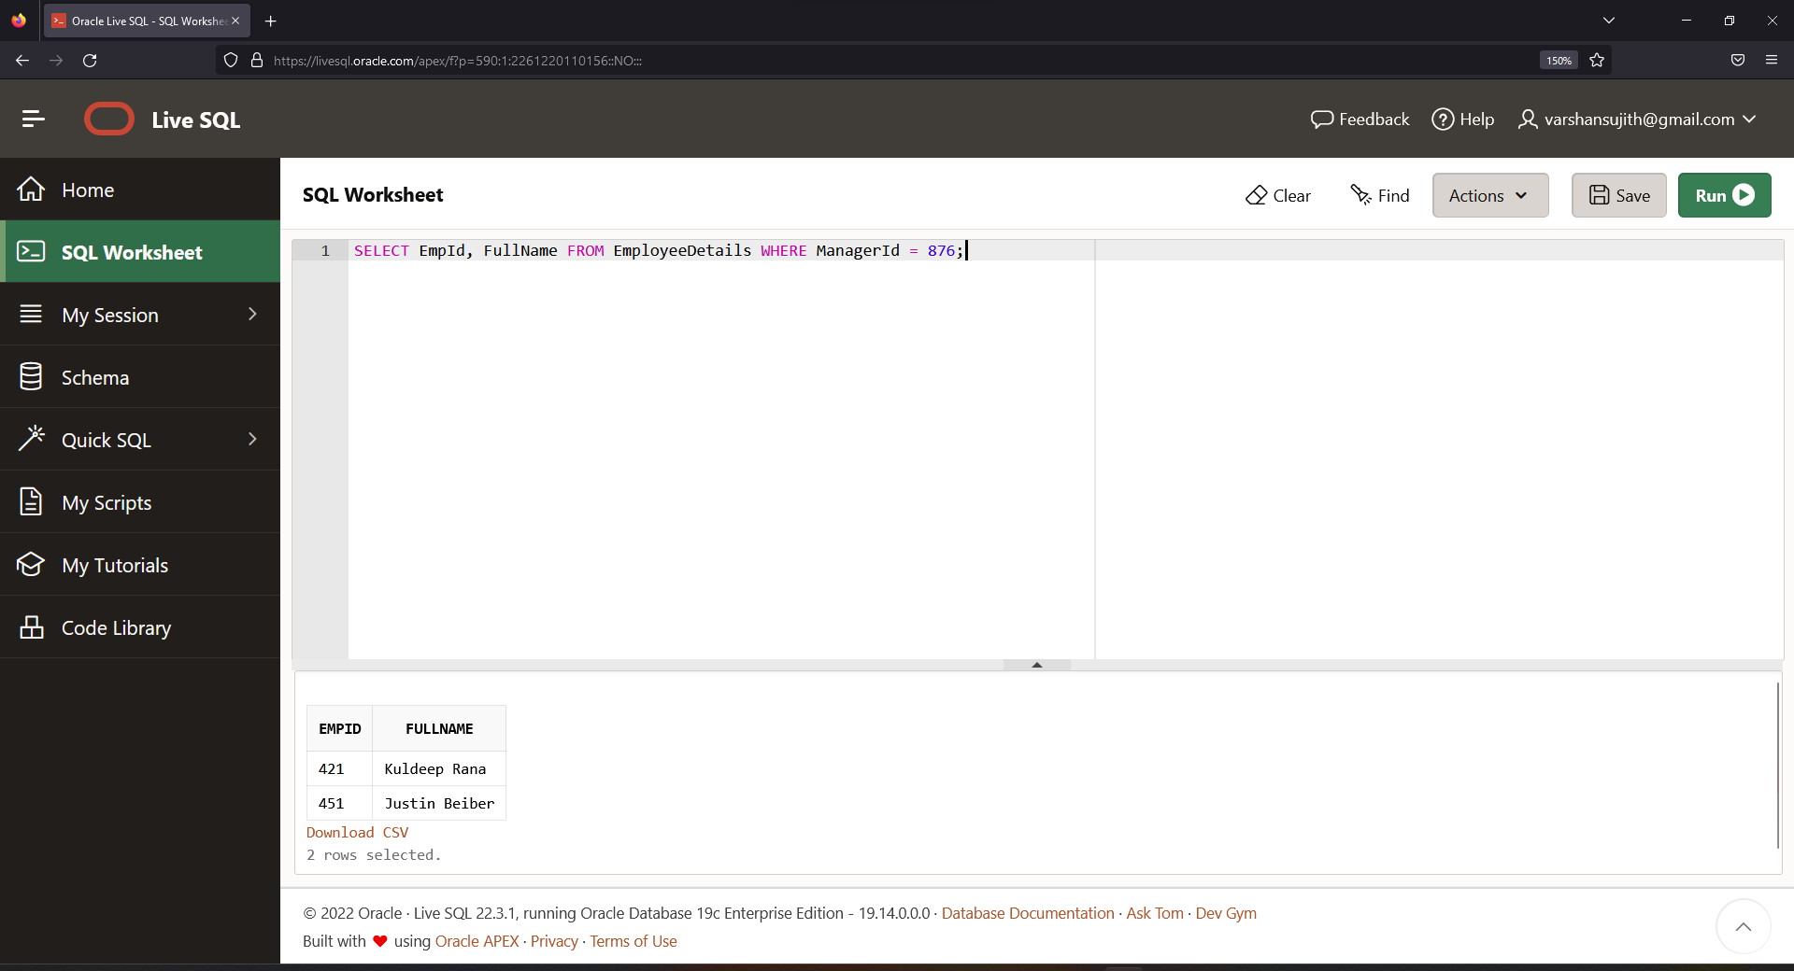

**Ques.2. Write an SQL query to fetch the different projects available from the EmployeeSalary table.**

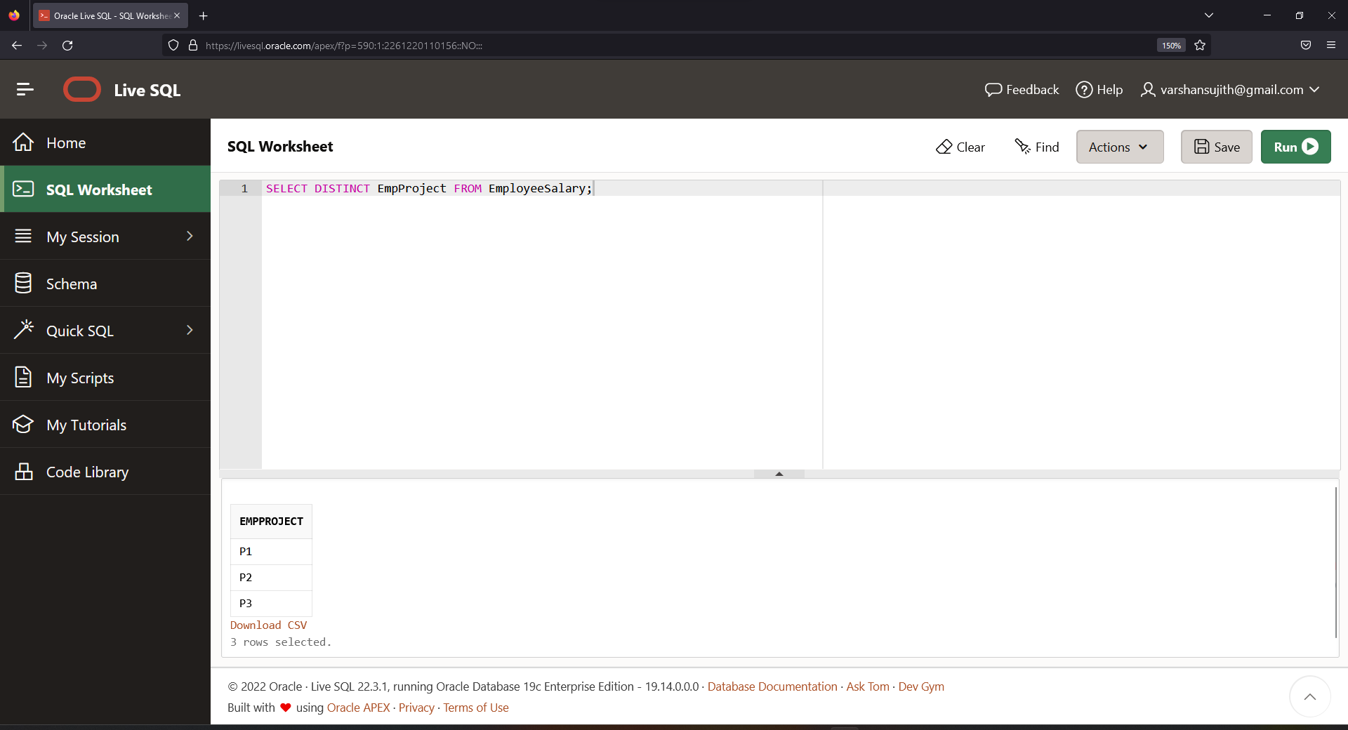

**Ques.3. Write an SQL query to fetch the count of employees working in project ‘P2’.**

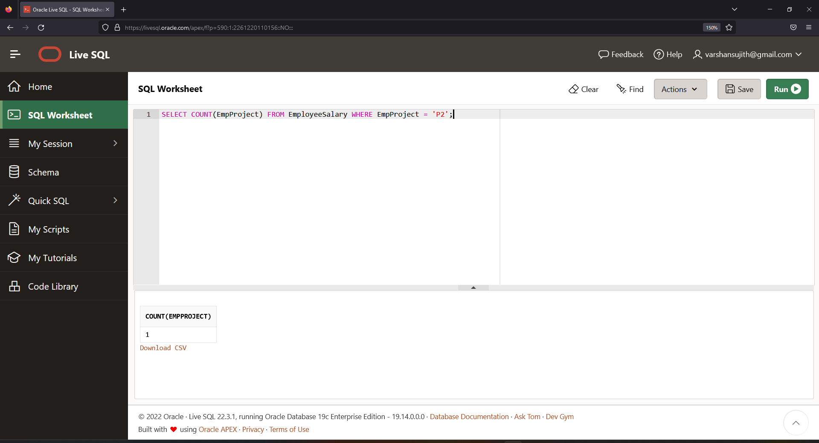

**Ques.4. Write an SQL query to find the maximum, minimum, and average salary of the employees.**

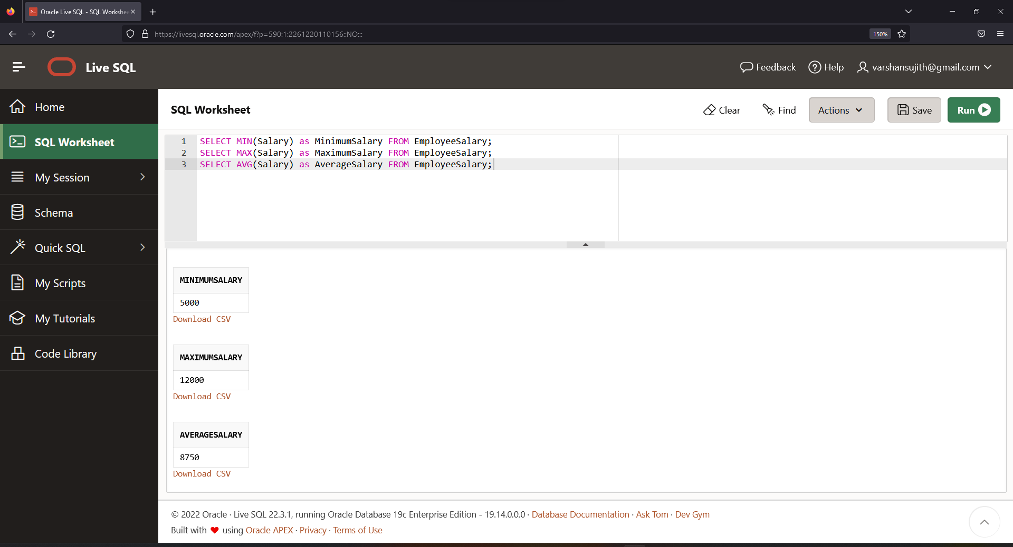

**Ques.5. Write an SQL query to find the employee id whose salary lies in the range of 10000 and 15000.**

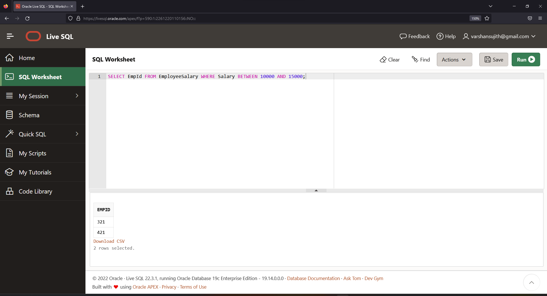

**Ques.6. Write an SQL query to fetch those employees who live in Toronto and work under manager with ManagerId – 121.**

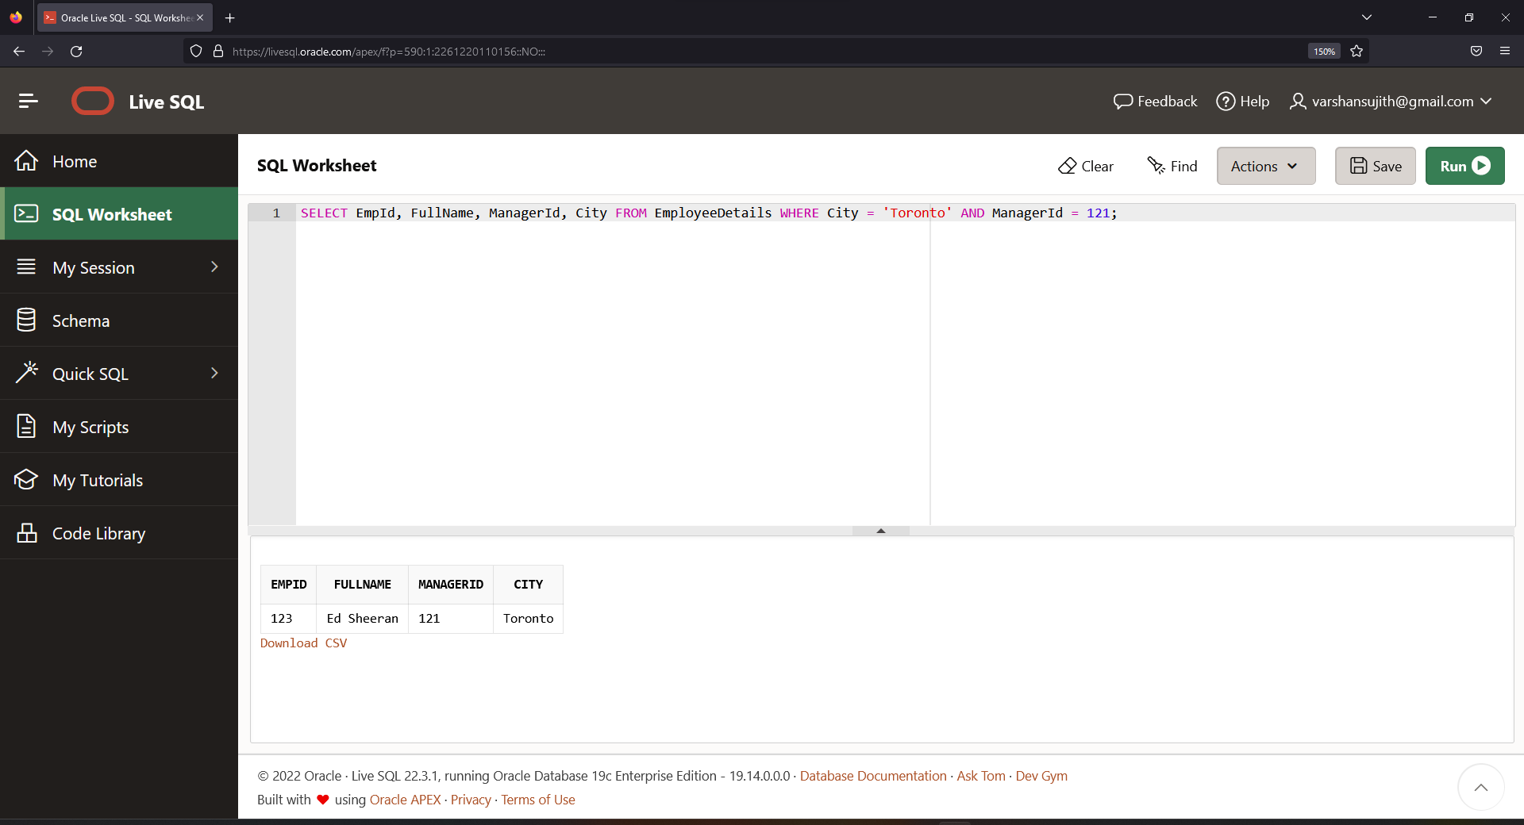

**Ques.7. Write an SQL query to** f**etch all the employees who either live in New Delhi or work under a manager with ManagerId – 321.**

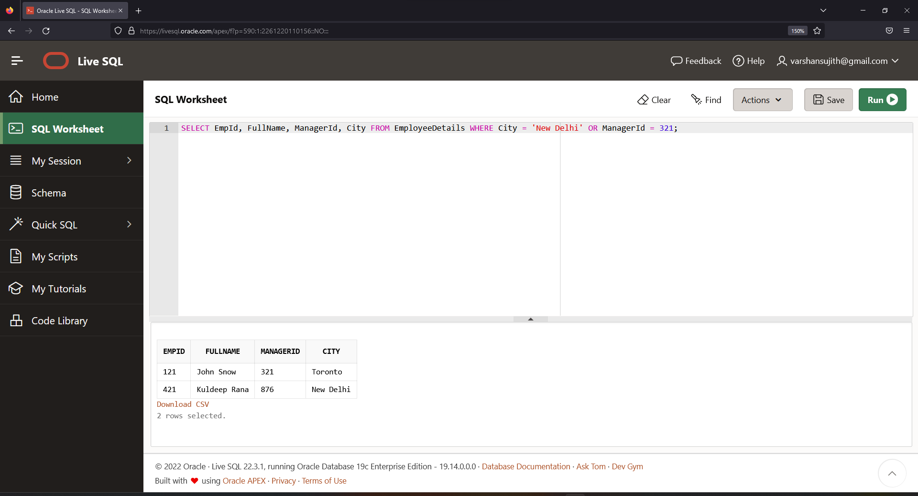

**Ques.8. Write an SQL query to fetch all those employees who work on Project other than P3.**

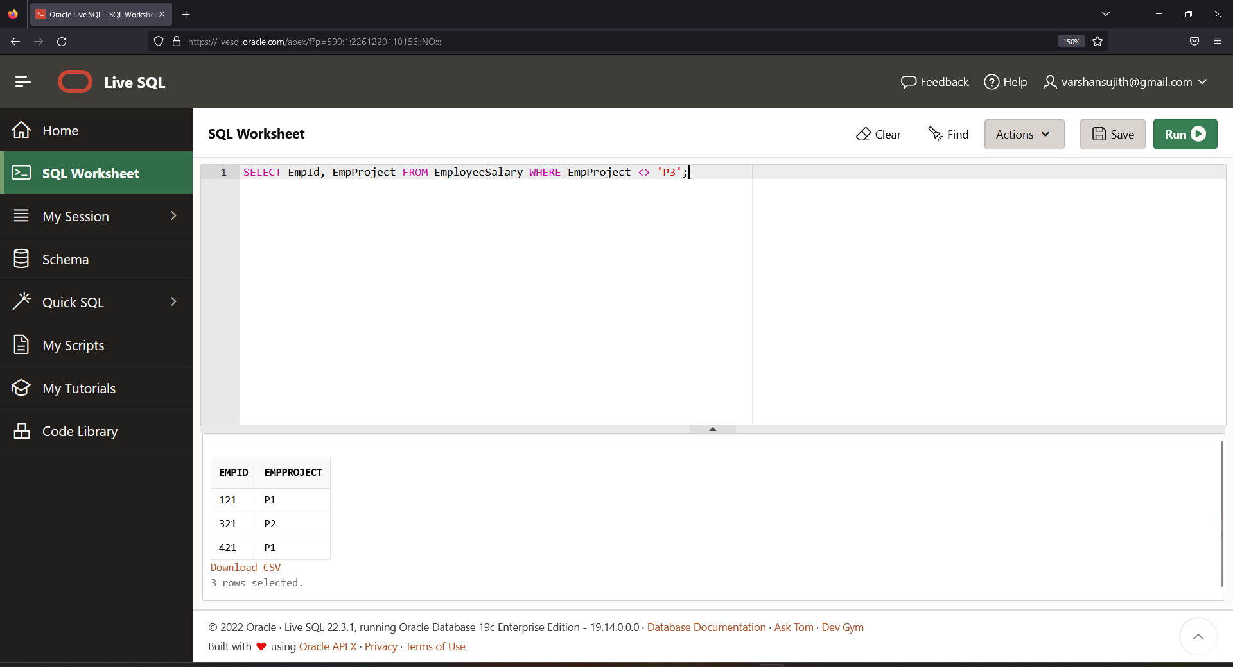

**Ques.9. Write an SQL query to display the total salary of each employee adding the Salary with Variable value.**

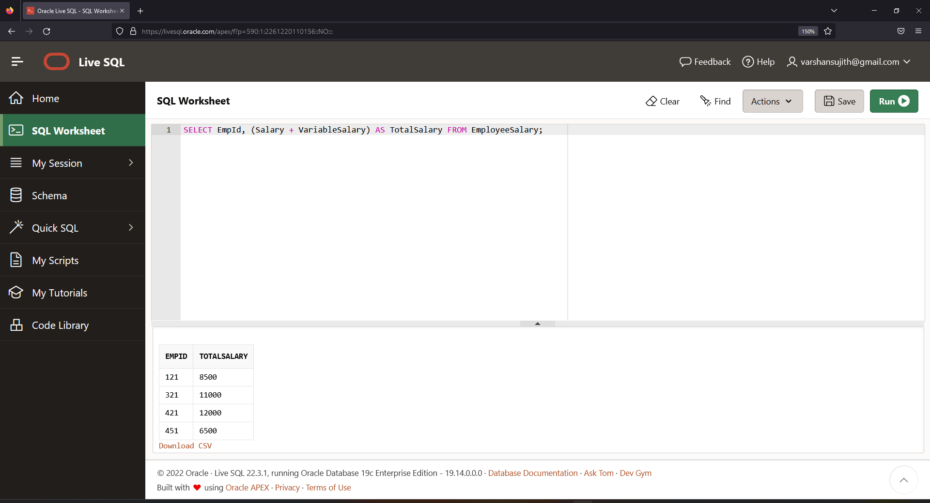

**Ques.10. Write an SQL query to fetch the employees whose name begins with any two characters, followed by a text “lt” and ending with any sequence of characters.**

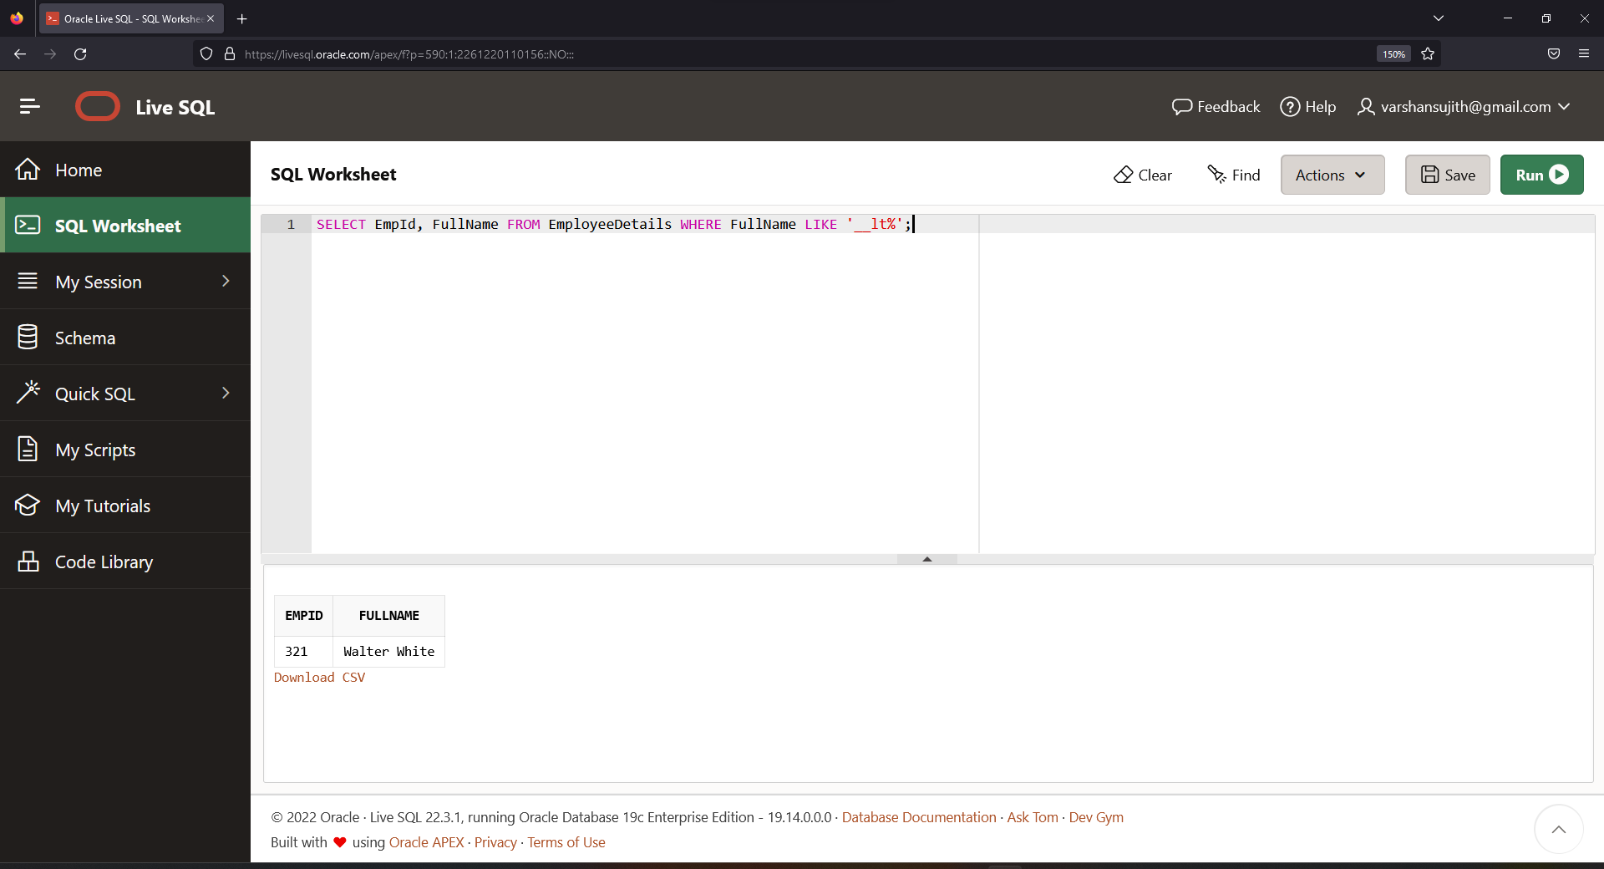

**Ques.11. Write an SQL query to fetch all the EmpIds which are present in either of the tables – ‘EmployeeDetails’ and ‘EmployeeSalary’.**

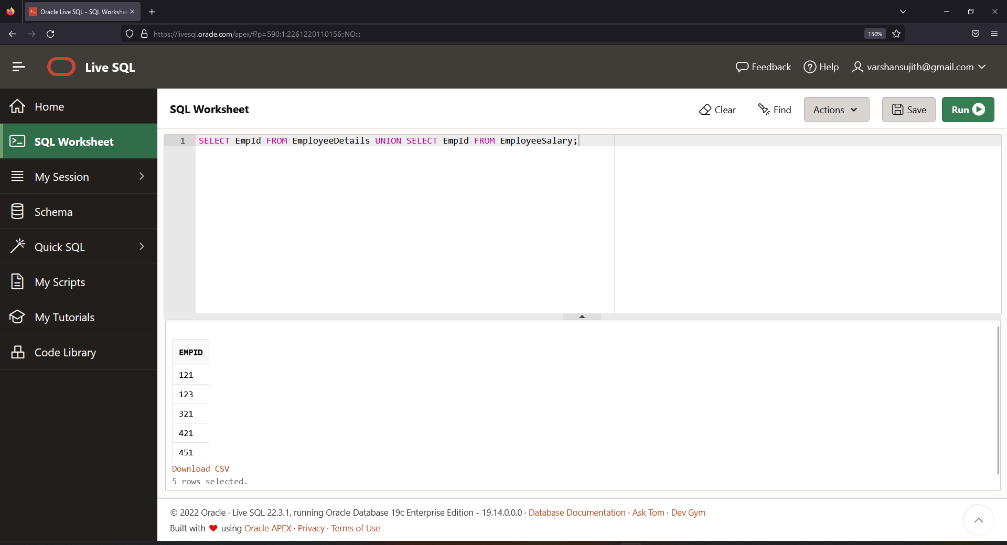

**Ques.12. Write an SQL query to fetch common records between two tables.**

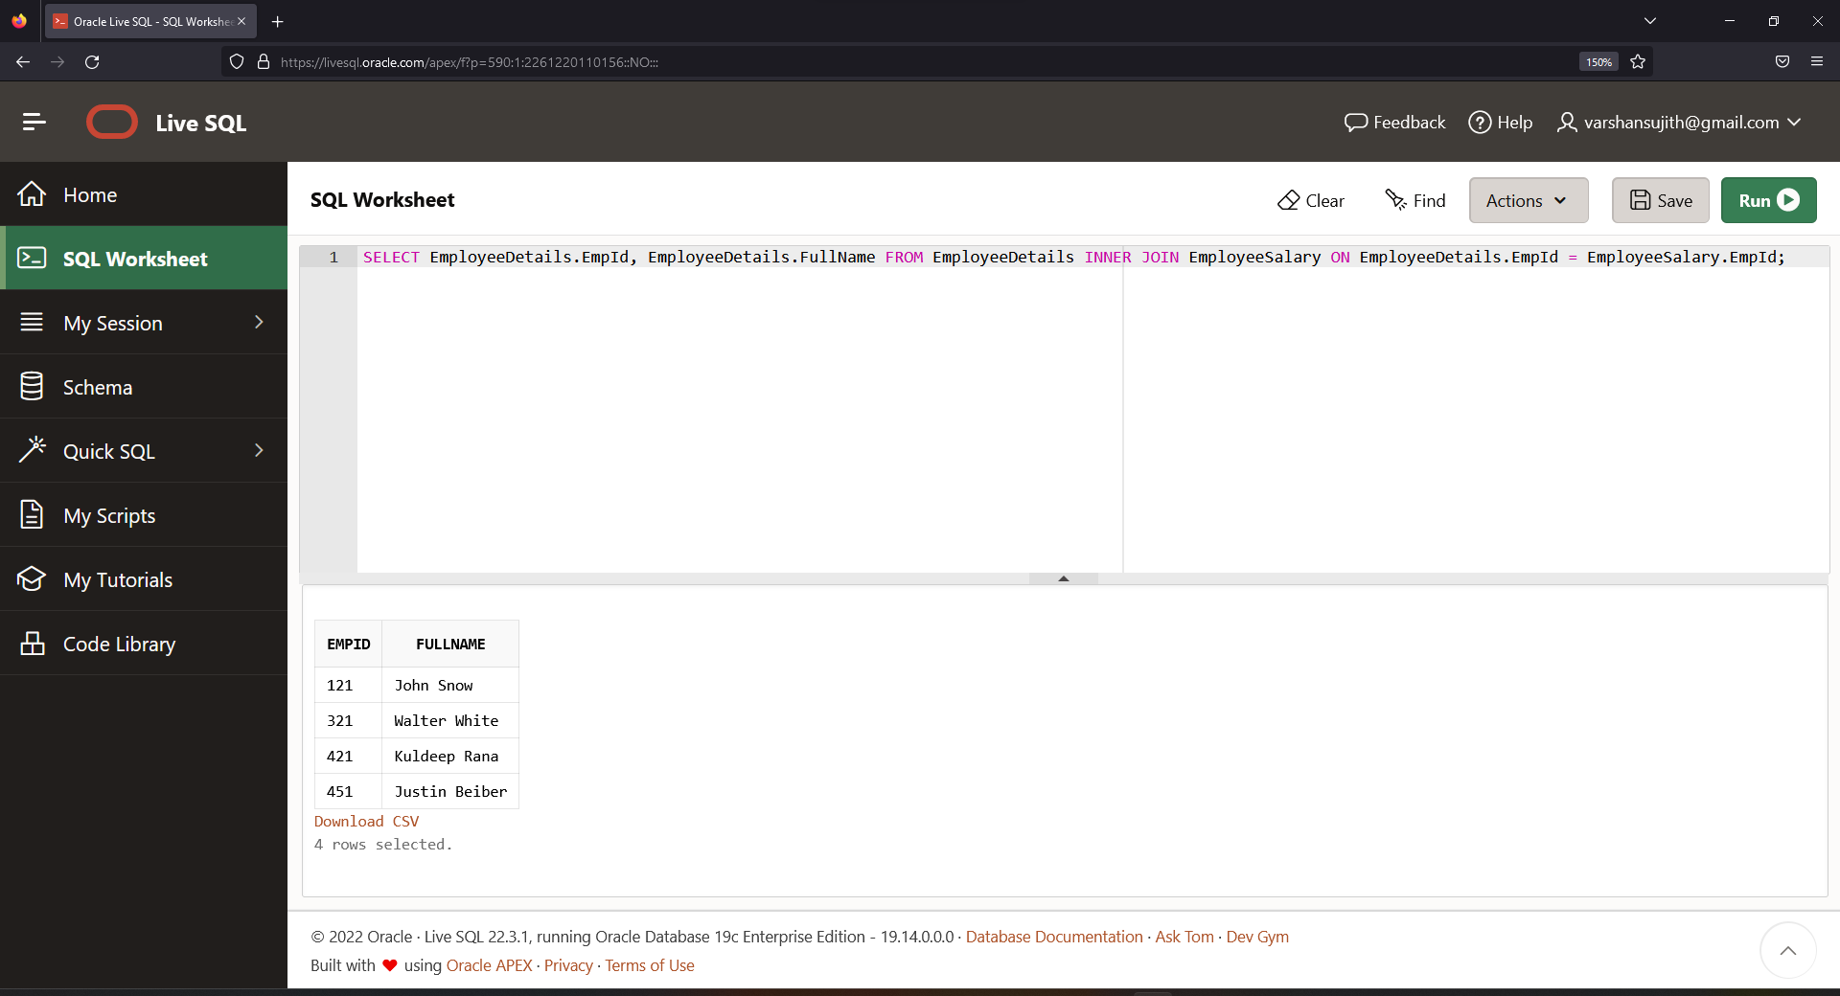

**Ques.13. Write an SQL query to fetch records that are present in one table but not in another table.**

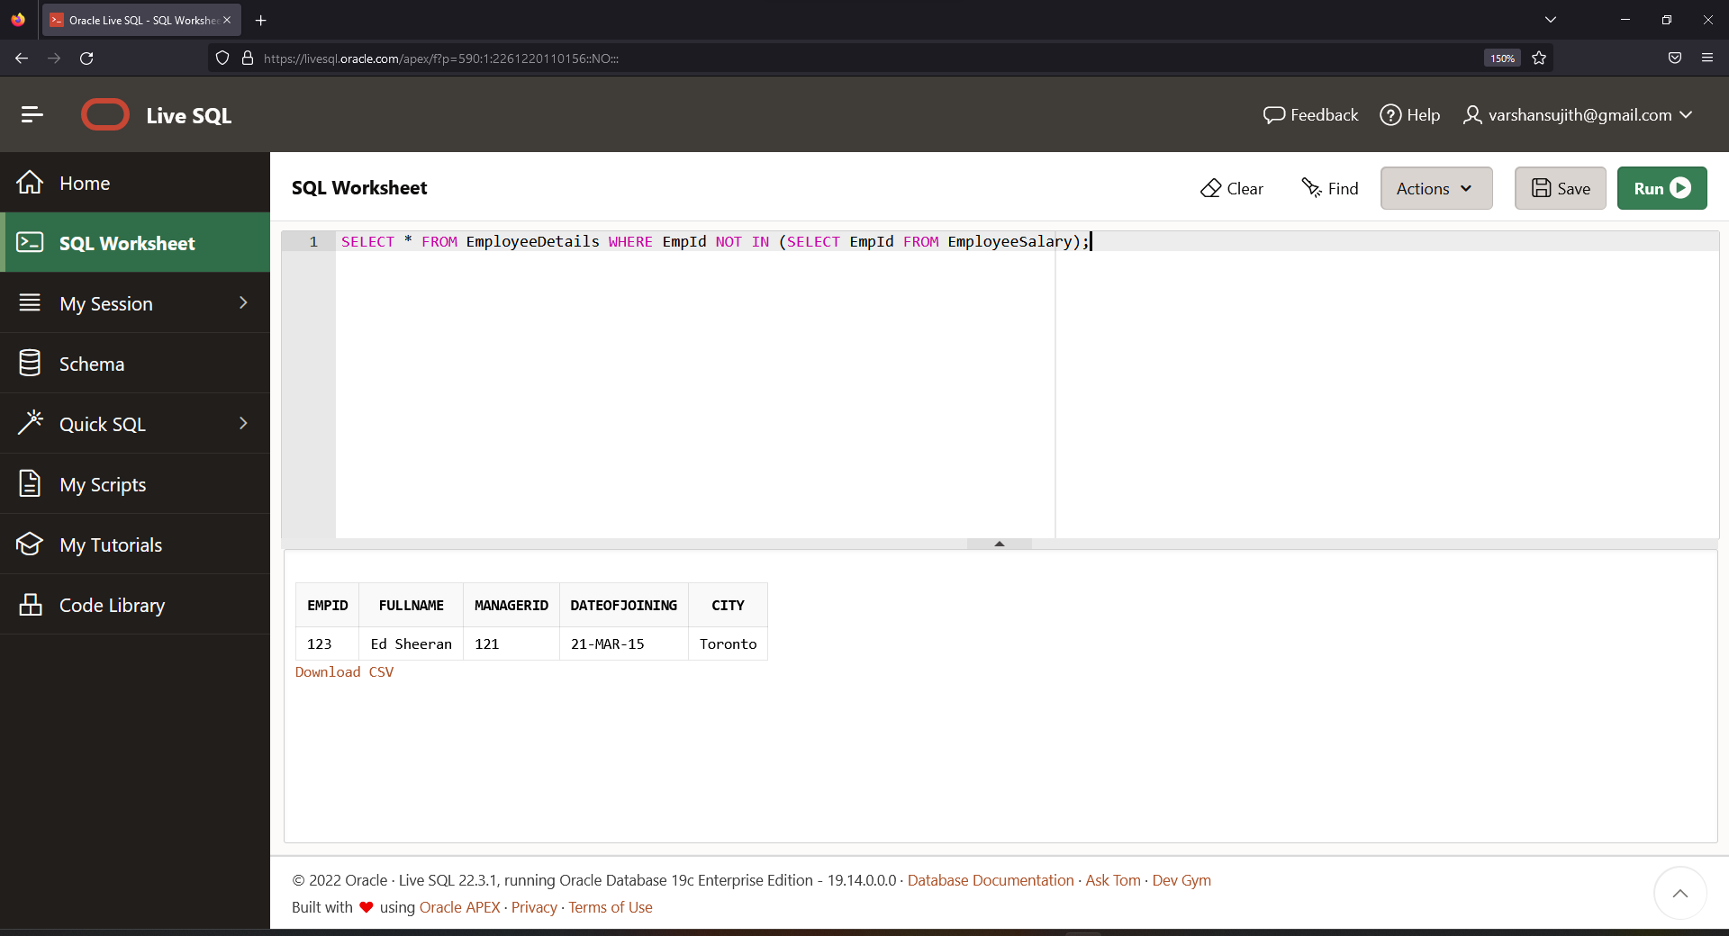

**Ques.14. Write an SQL query to fetch the EmpIds that are present in both the tables –   ‘EmployeeDetails’ and ‘EmployeeSalary.**

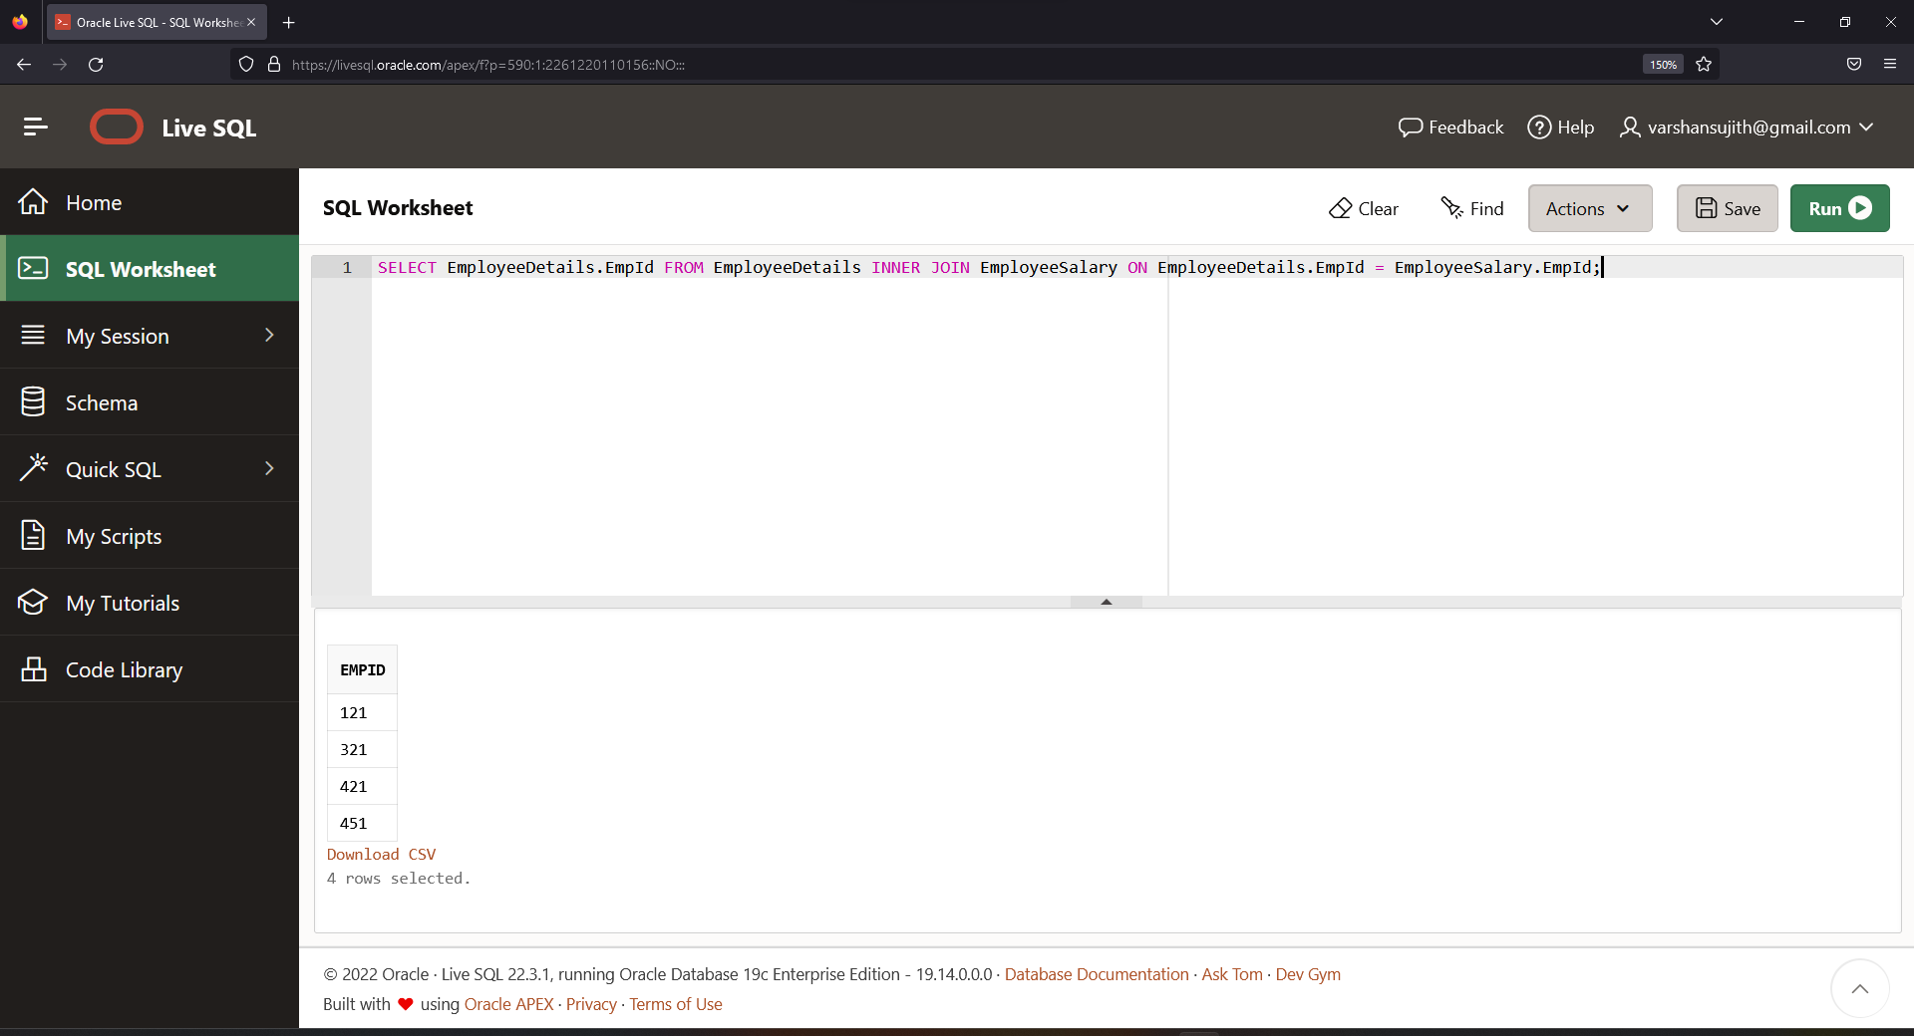

**Ques.15. Write an SQL query to fetch the EmpIds that are present in EmployeeDetails but not in EmployeeSalary.**

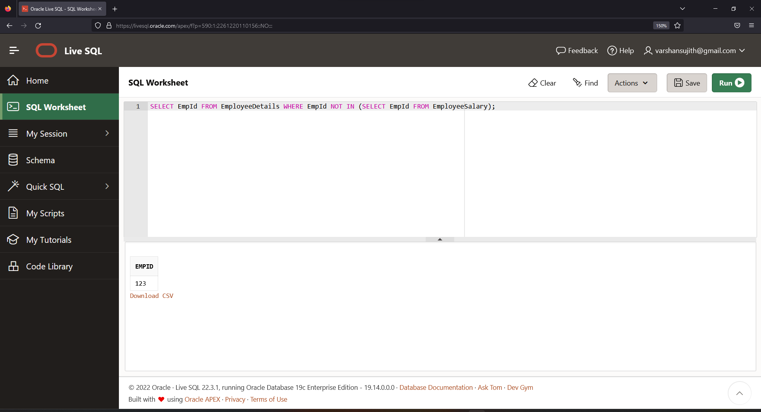

**Ques.16. Write an SQL query to fetch the employee full names and replace the space with ‘*’.**

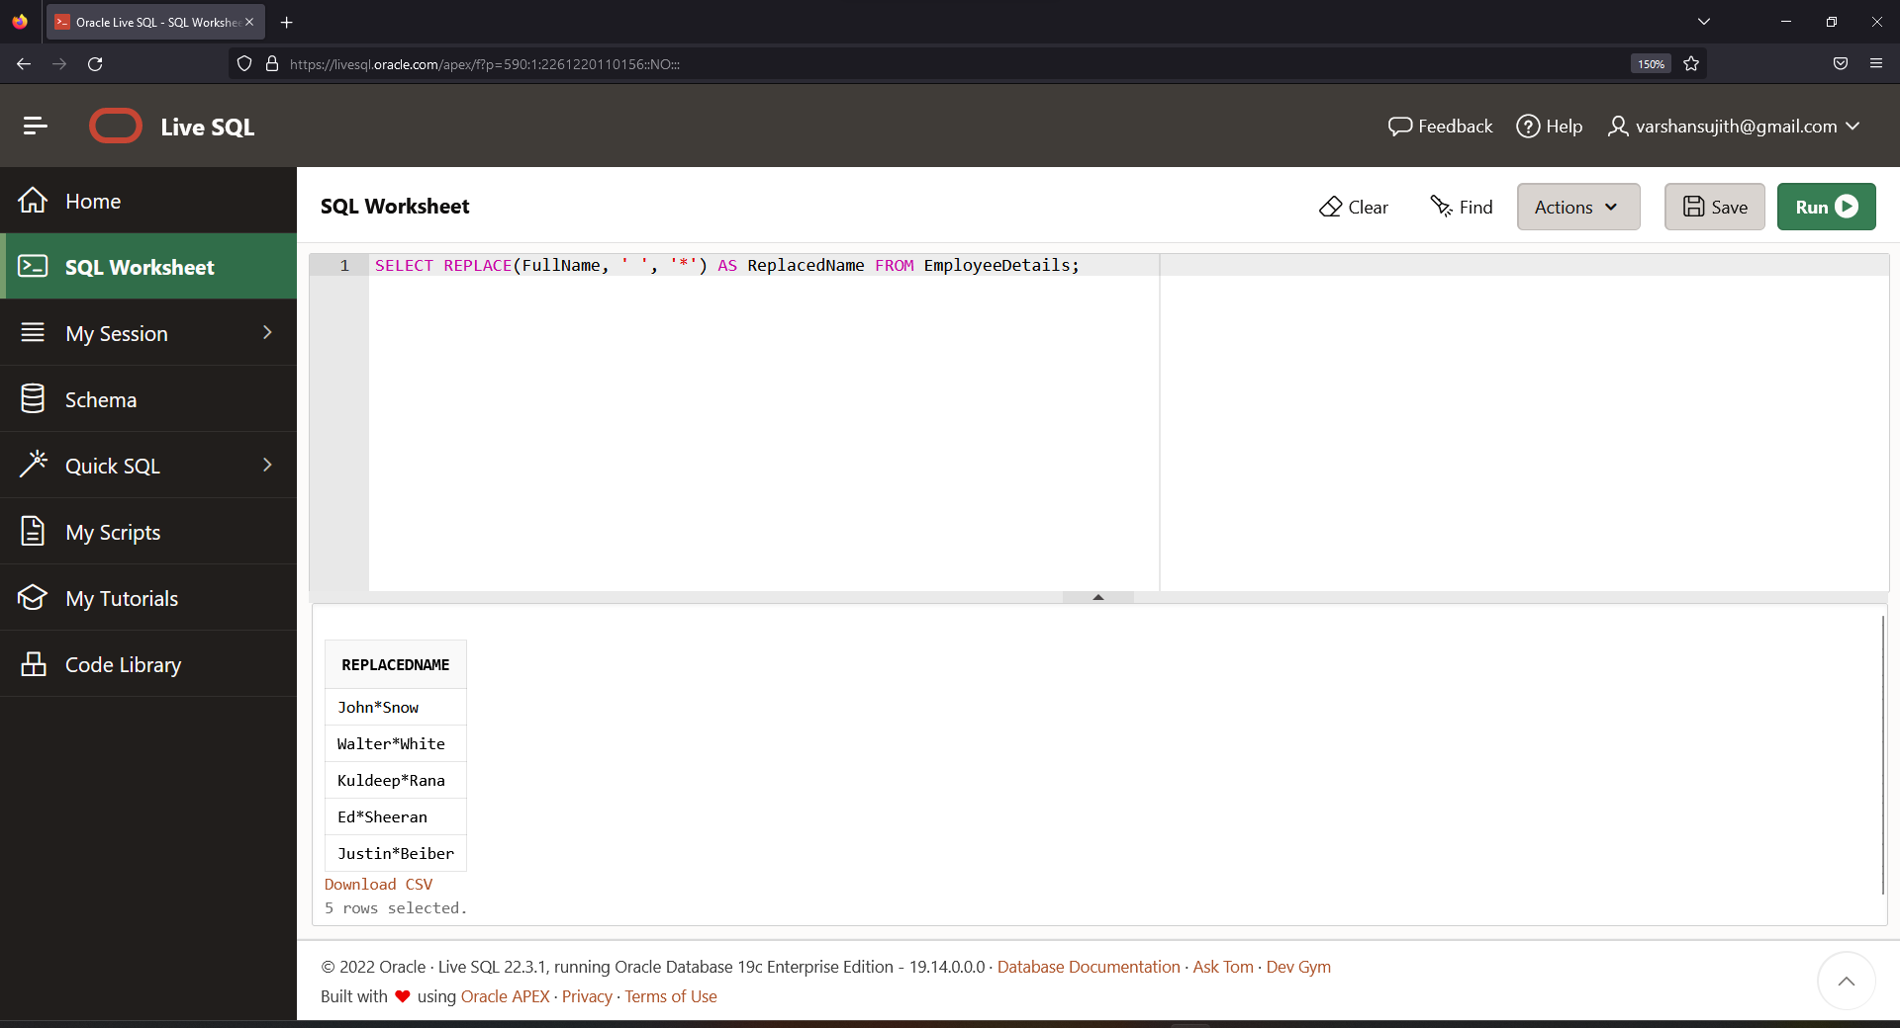

**Ques.17. Write an SQL query to fetch the position of a given character(s) in a field.**

**Ques.18. Write an SQL query to display both the EmpId and ManagerId together.**

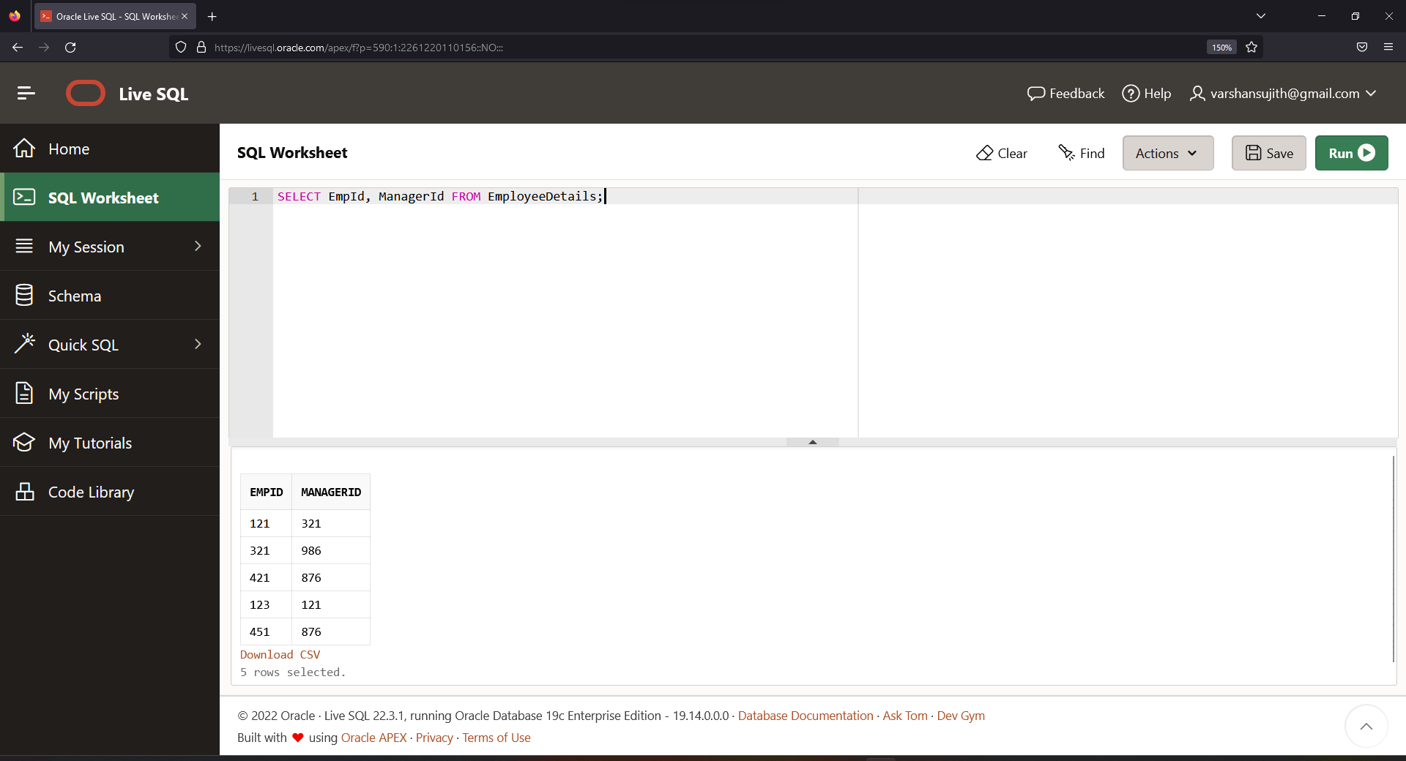

**Ques.20. Write an SQL query to upper case the name of the employee and lower case the city values.**

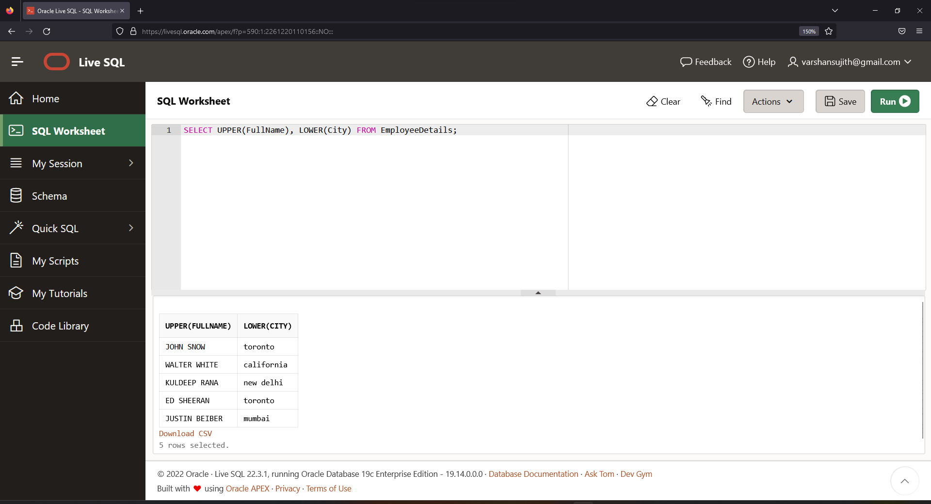

**Ques.21. Write an SQL query to find the count of the total occurrences of a particular character – ‘n’ in the FullName field.**

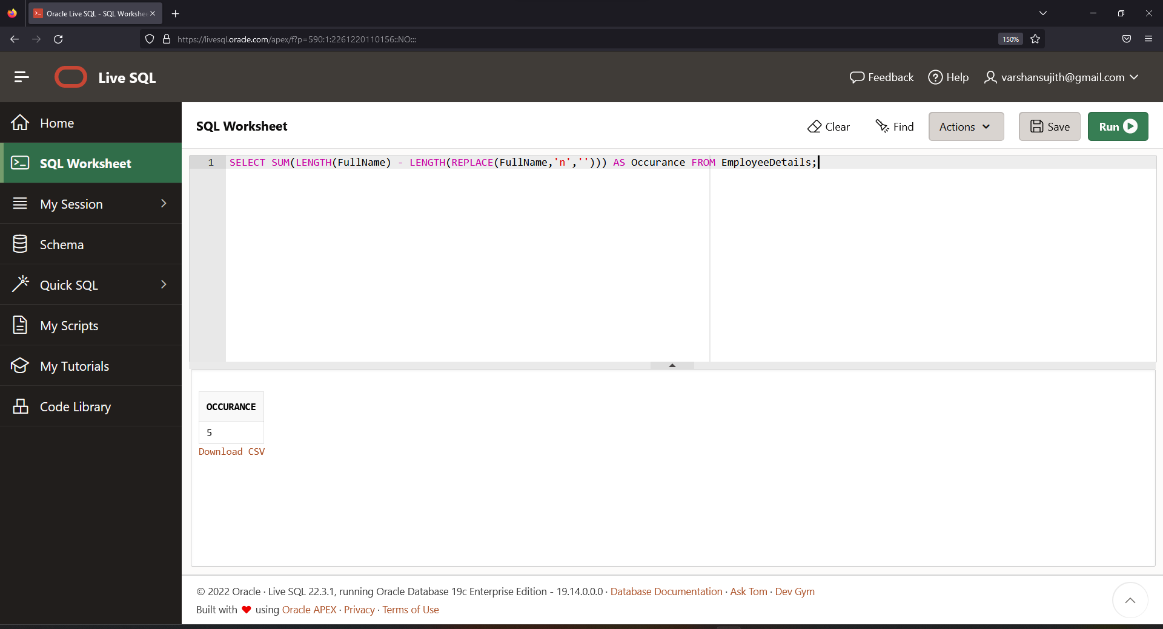

**Ques.22. Write an SQL query to update the employee names by removing leading and trailing spaces.**

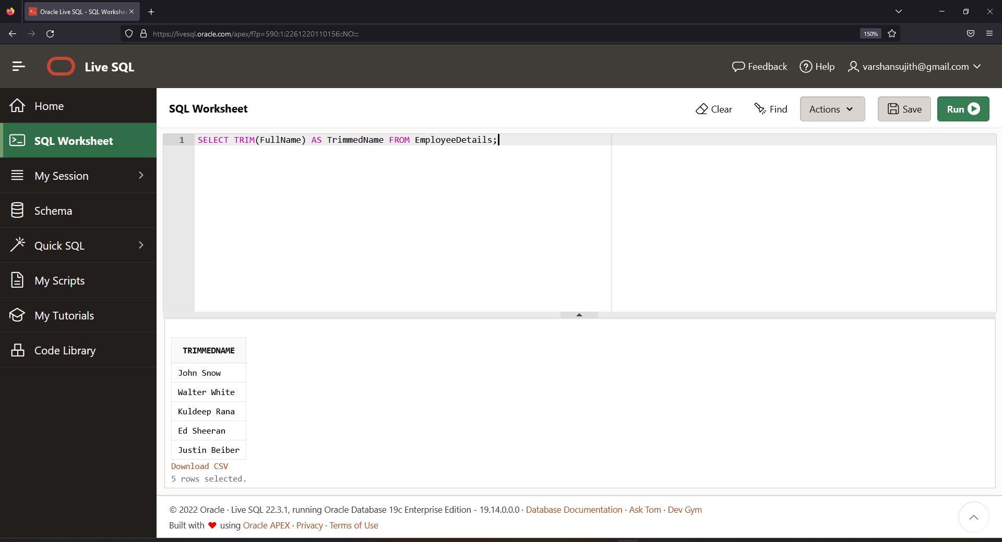

**Ques.23. Fetch all the employees who are not working on any project.**

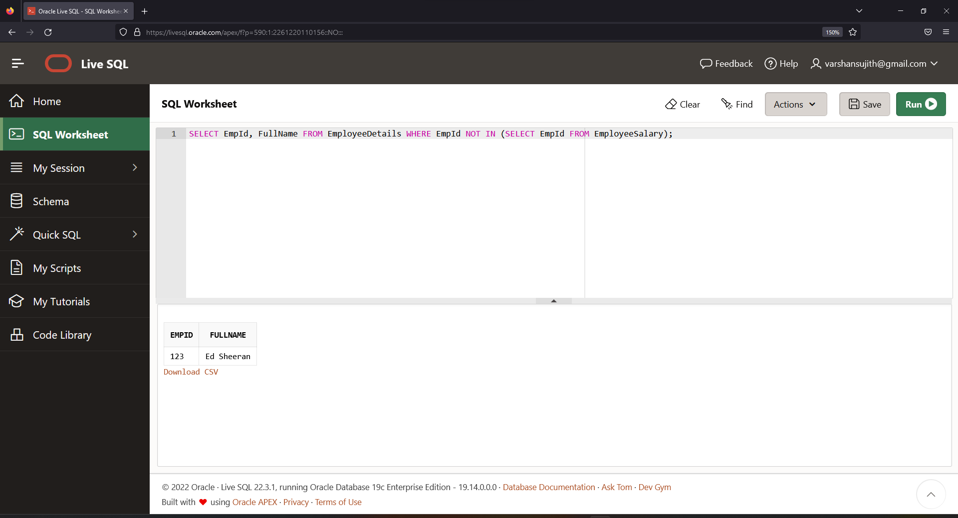

**Ques.24. Write an SQL query to fetch employee names having a salary greater than or equal to 5000 and less than or equal to 10000.**

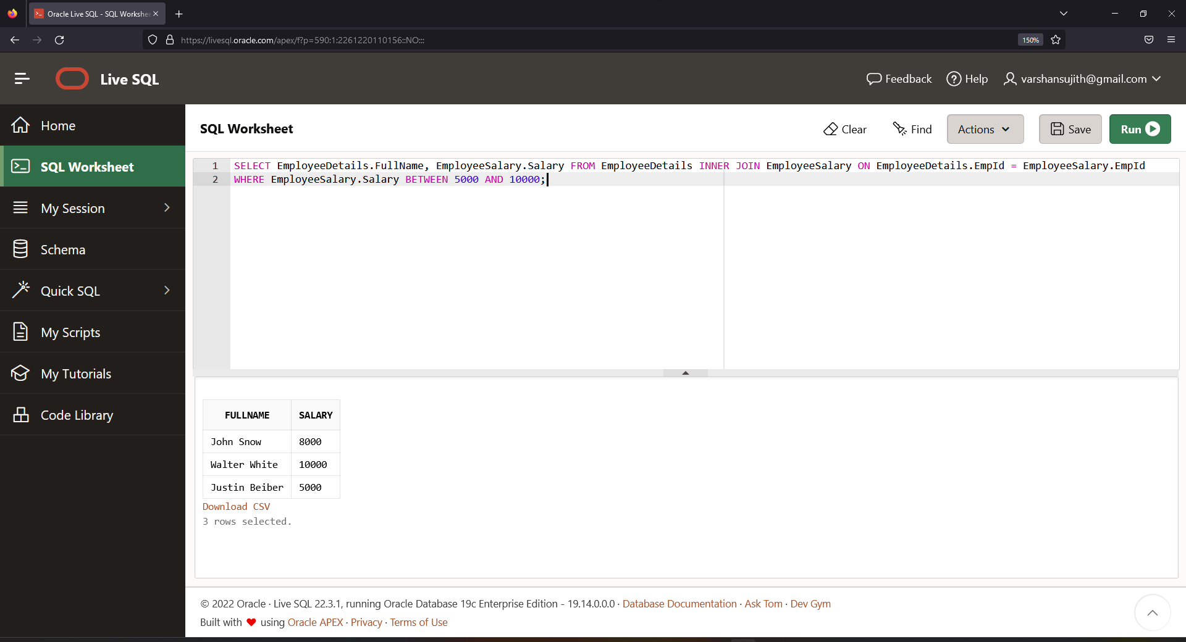

**Ques.25. Write an SQL query to find the current date-time.**

**Ques.26. Write an SQL query to fetch all the Employees details from EmployeeDetails table who joined in the Year 2016.**

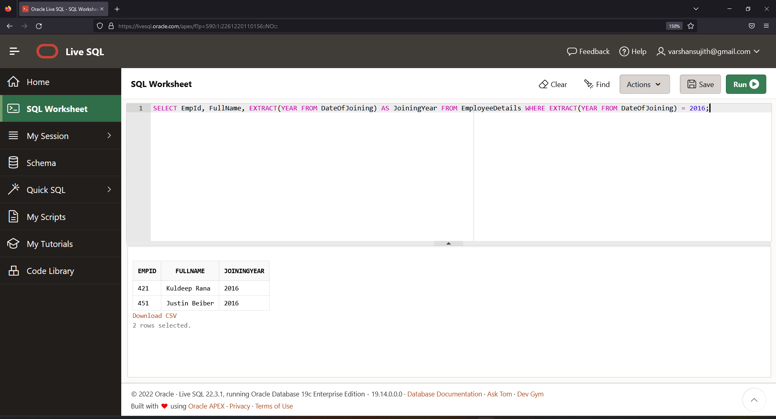

**Ques.27. Write an SQL query to fetch all employee records from EmployeeDetails table who have a salary record in EmployeeSalary table.**

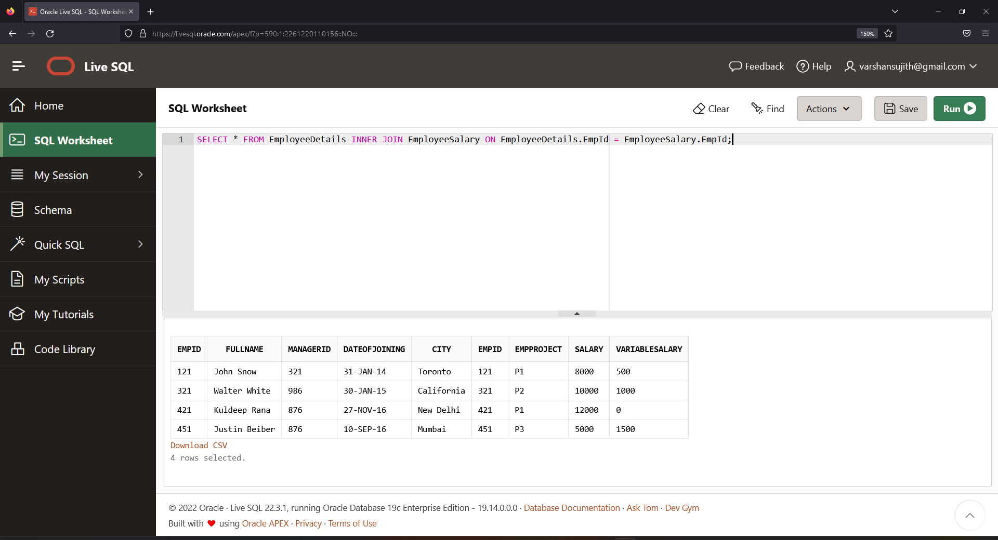

**Ques.28. Write an SQL query to fetch project-wise count of employees sorted by project’s count in ascending order.**

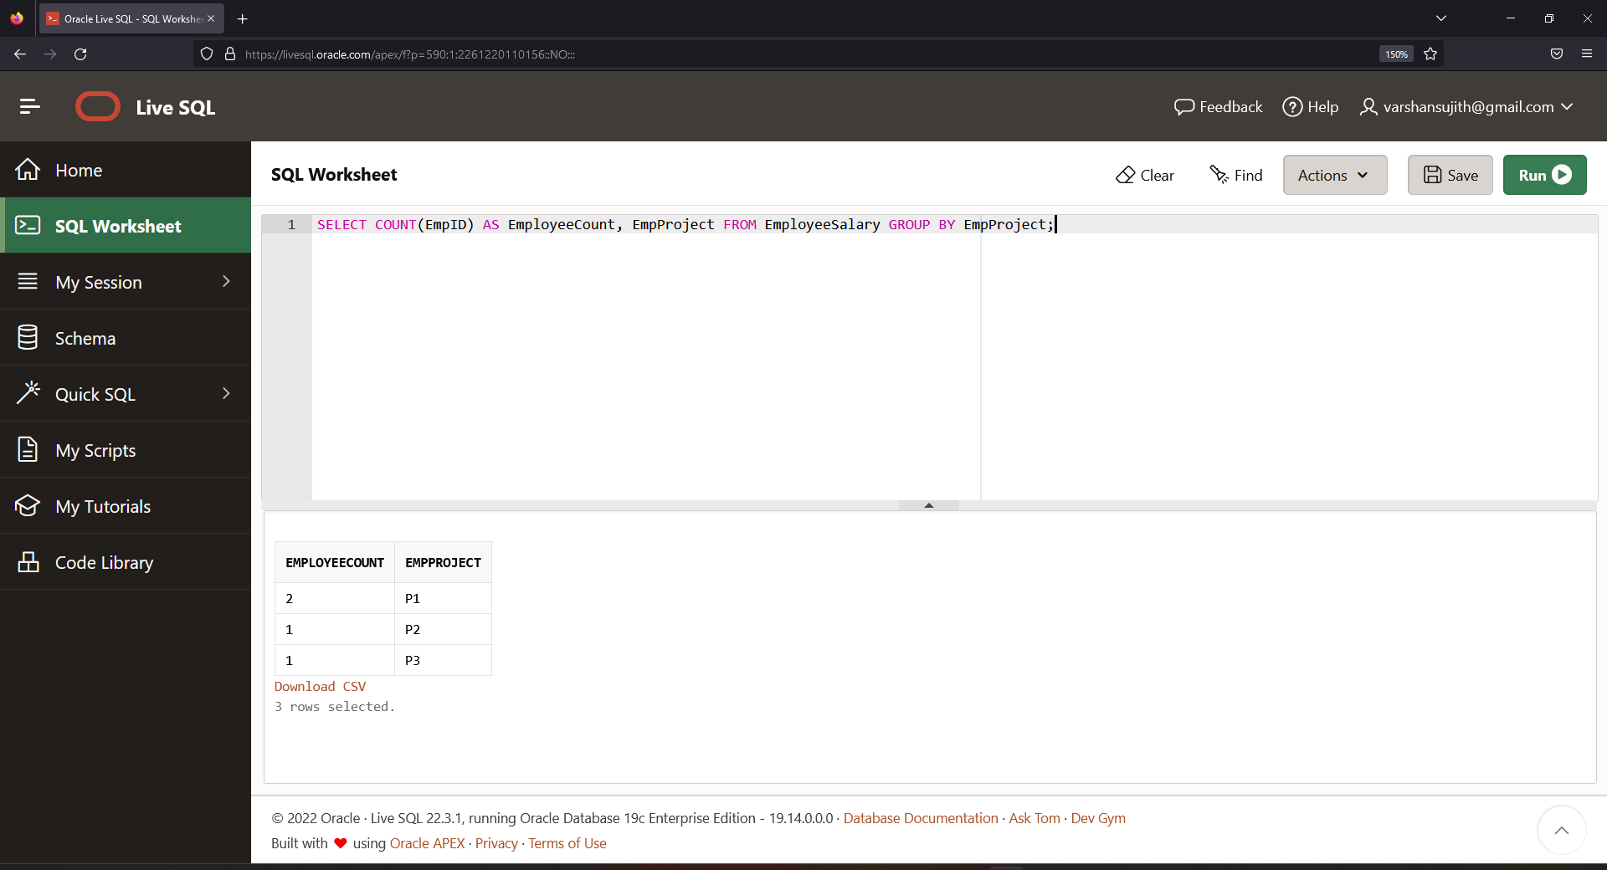

**Ques.29. Write a query to fetch employee names and salary records. Display the employee details even if the salary record is not present for the employee.**

